# What is Azure Blob storage

Azure blob is Microsoft's object storage storage solution for the cloud. Blob storage is optimized for storing massive amounts of unstructured data. Unstructured data is data that does not adhere to a particular data model or definition, such as text or binary data.

# Why Blob?

Blob storage is one of the export option from Azure IoT Central. Storing data in Central that was received from the IoT device allow us to do more with the data.

# Setting up Blob

1. Log in to Azure Portal

2. Select Storage Accounts

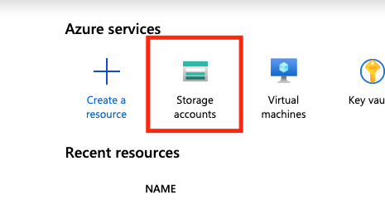

3. Add a new storage account

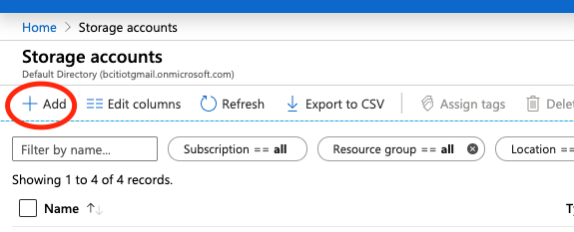

4. Select Blob storage for the Account kind and Cool for Access tier.

5. Enter blob storage and select Containers in Blob service

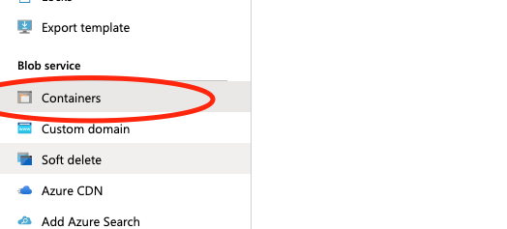

6. Add a new container

# Export data from IoT Central to Blob storage

1. Select Export data on the side menu.

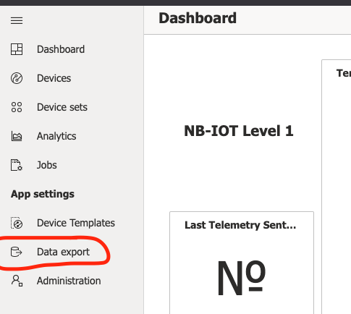

2. Click on "New" button and select "Azure Blob Storage"

3. On the Blob Storage section, select your Storage account and Container you just created. Set the data format to Avro.

Note: All data in Blob is automatically encrypted. There is no way to decrypt the data using Azure Blob API. And avro files are more readable, so we are using avro.

4. Once you clicked save, the export will start to setup and you just have to wait for the data to show up in blob. In order to do that, enter Blob storage and select the container you created. Once the data is exported correctly, you should see this:

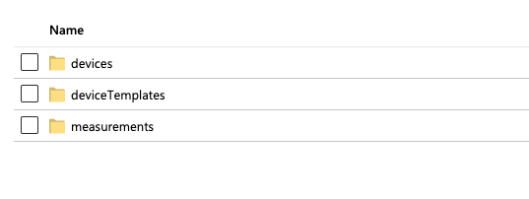

All data is exported to your storage account once per minute, with each file containing the batch of changes since the last exported file. The default paths in your storage account are:

* Messages: {container}/measurements/{hubname}/{YYYY}/{dd}/{hh}/{mm}/{filename}
* Devices: {container}/devices/{hubname}/{YYYY}/{dd}/{hh}/{mm}/{filename}
* Device templates: {container}/deviceTemplates/{hubname}/{YYYY}/{dd}/{hh}/{mm}/{filename}

For more information you can visit this website:

<https://docs.microsoft.com/en-us/azure/iot-central/core/howto-export-data-blob-storage>

Note: before testing the code with your data, you need your Blob's connection string.

1. The connection string is located at Blob storage page in Azure portal. On the left panel, select Access keys.

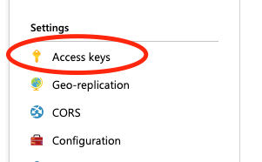

2. Copy the Connection string under key1

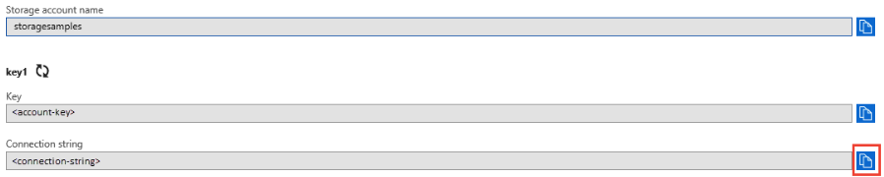

3. Now replace the Connection string in the code. Located in App.java line 9

4. Replace the CONTAINER_NAME string with your container name as well.

5. Run the program and it should give you something like this:

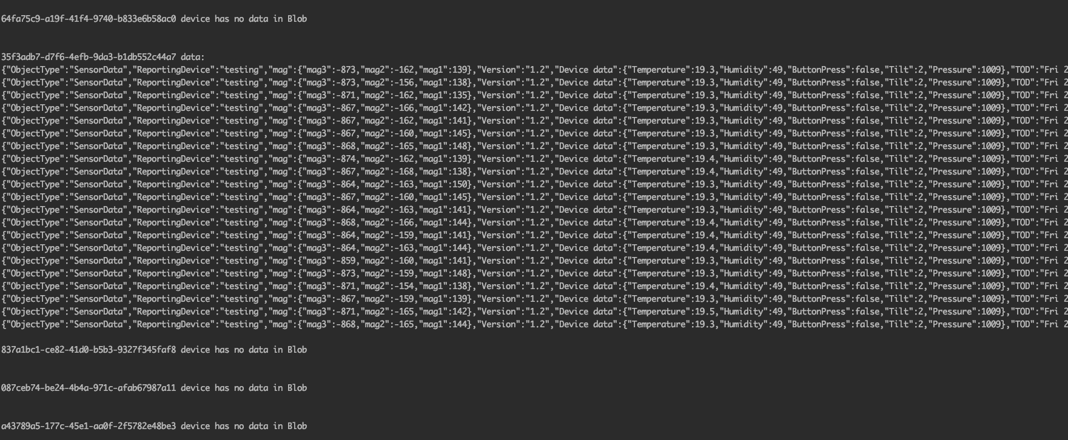

Congratution, your all done!